GASSENGER

BY

Abdullah Aman(1405038)

Chashi Mahiul Islam (1405060)

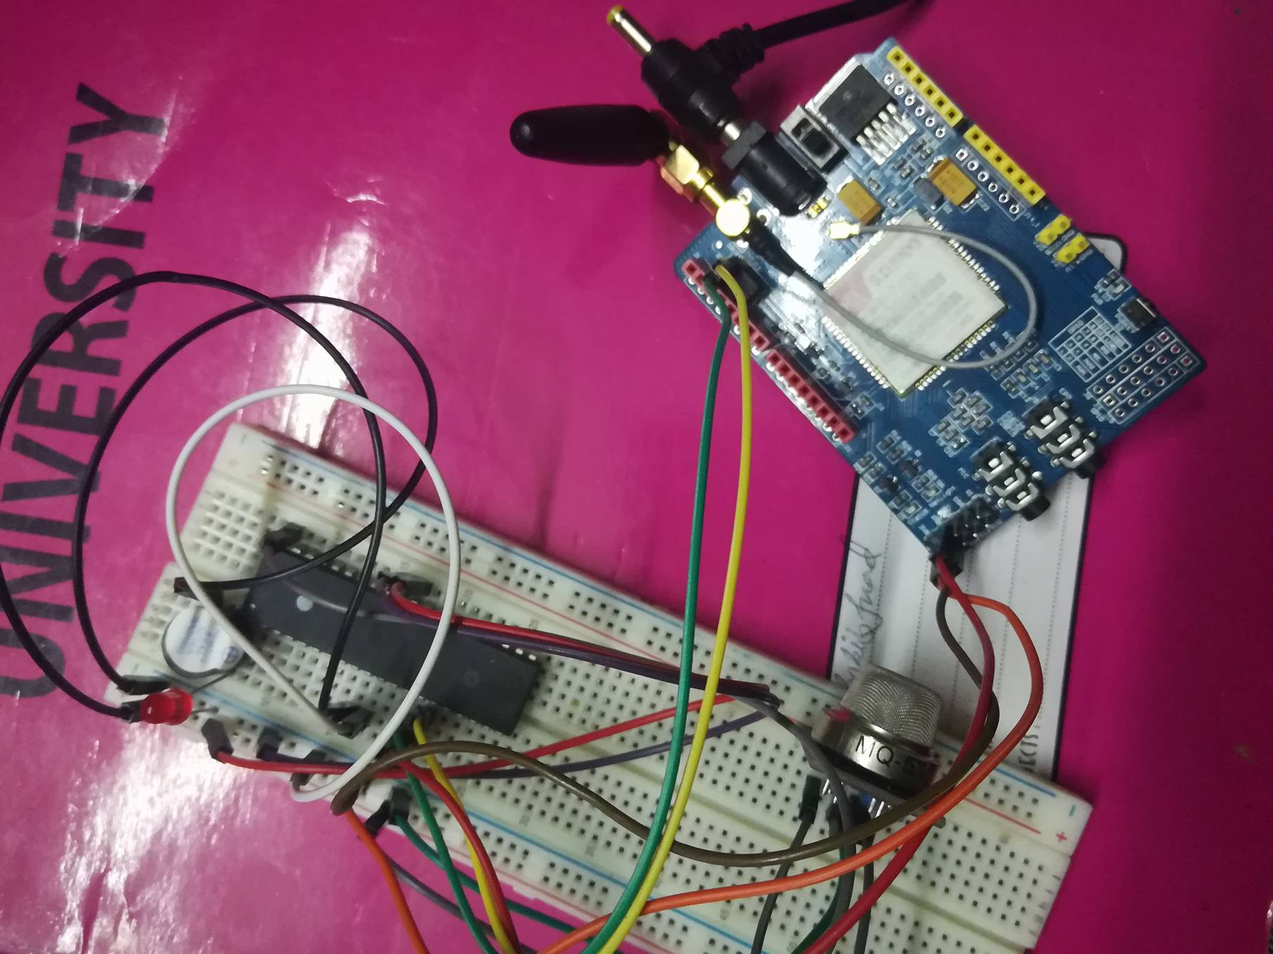

INTRODUCTION:

The main objective of our project is to make a system which can detect if there is any gas leakage in kitchen or any such area .Then it will send an emergency message to the appropriate person to handle the problem and a buzzer will sound, a light will glow as signal to gas leakage. We have made this system by interfacing atmega 32 with led light,mg5 gas sensor which detect the density of gas in the environment and the gsm sim 900 A module which h will send emergency sms to the owner’s mobile number.

HARDWARE REQUIREMENTS:

|  |  |
| --- | --- |
| COMPONENT NAME | COST(TK) |
| Atmega 32 microcontroller | 500 |
| GSM SIM-900 A MODULE | 1600 |
| MQ-5 LPG GAS SENSOR | 120 |
| BUZZER | 10 |
| Capacitors | 10 |
| 120 V 2 amp AC-DC adapter | 80 |
| Male to male wires | 30 |
| Male to female wires | 30 |
| USB ISP 2.0 AVR Programmer | 300 |
| Match light | 10 |
| Any Sim with enough recharge money | 200tk |
| Battery Box | 30tk |
| 4 piece 1.5 volt battery | 60tk |

SOFTWARE REQUIREMENTS:

List of softwares required for this project are as follows:

●ATmel Studio 7 (to compile .c code and build .hex and .eep file)

● eXtreme Burner - AVR (to load .hex and .eep file onto ATmega32)

● Proteus 8 Professional (for circuit design)

FLOW CHART:

[Grab your reader’s attention with a great quote from the document or use this space to emphasize a key point. To place this text box anywhere on the page, just drag it.]

No

yes

Digitalvolt>=1.5

Digitalvolt=digital output voltage of atmgea

Insert analoguevolt as input in atmega to get digital output voltage

Anologuevolt= analog output voltage of gas sensor

Simulate gas sensor and sim module

Wait for until sms sent

Ring buzzer,light up led,send sms by gsm

BLOCK DIAGRAM:

Showing input and output

120 V 2 amp adapter

Sim900 A module

Buzzer

LEDS

MG5 gas sensor

Atmega32

ACTUAL CIRCUIT DIAGRAM:

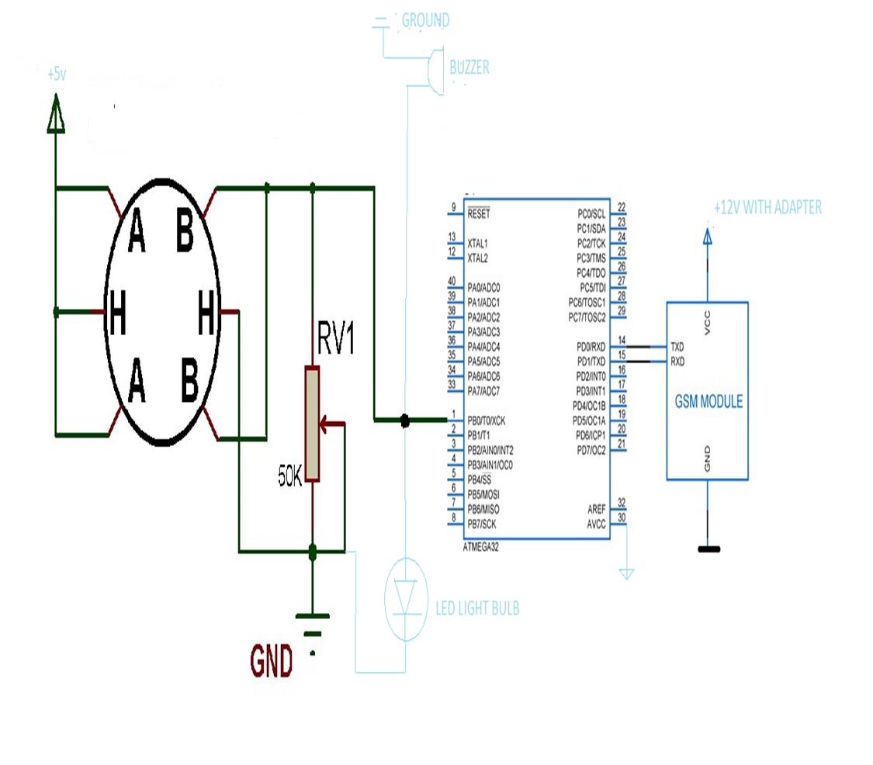

ACTUAL CIRCUIT:

Snapshop of our working circuit

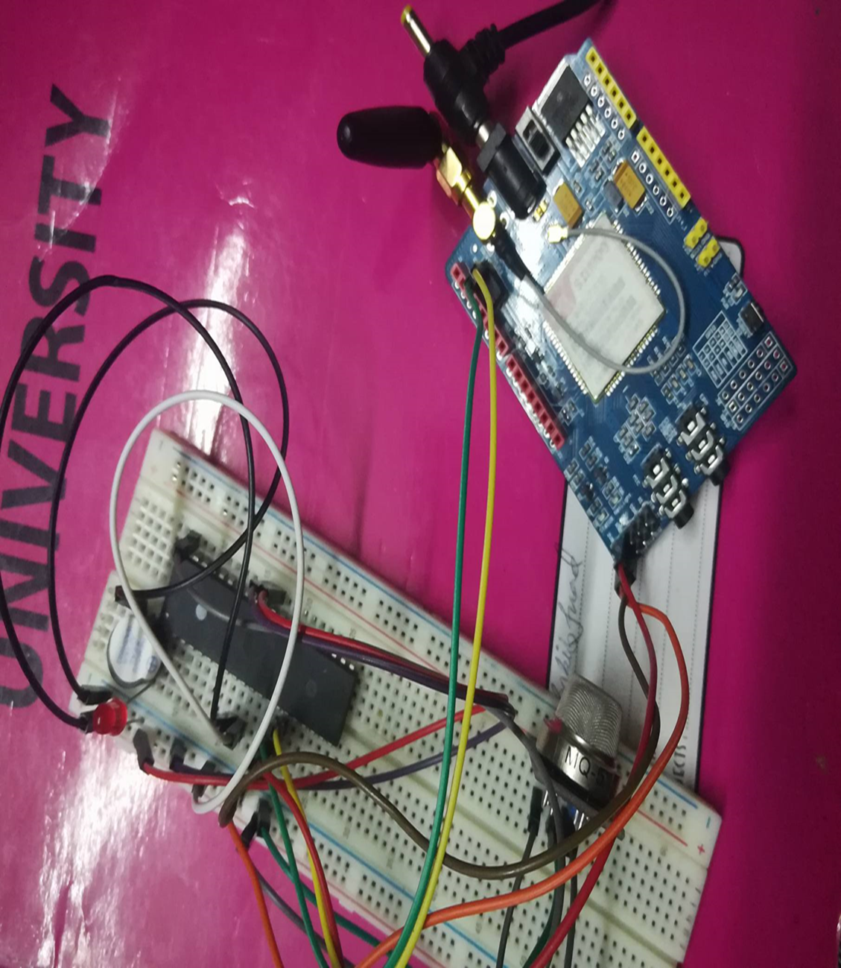

Basic Working Principle:

Sim 900 A Module:

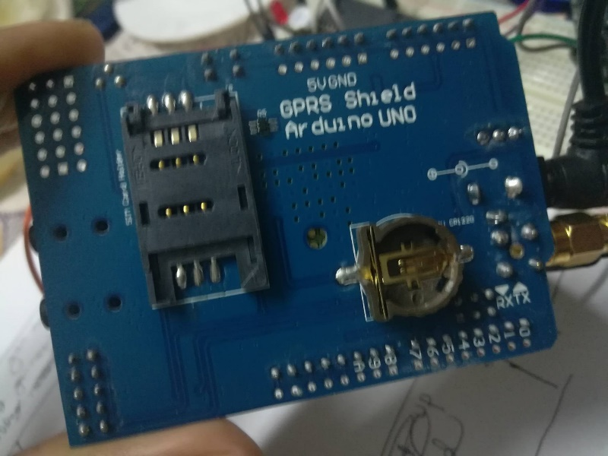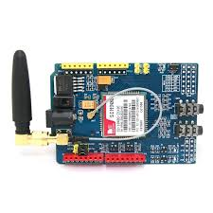In sim 900 A module we give power by 12 V 2 amp

Adapter because with this specific voltage and current

This module doesn’t work.There is a sim slot at the back side of the module to insert the sim card from which number the message will be sent.

Connections to atmega32:

●serial rx pin to atmega 32’s tx (pin 15) pin

●serial tx pin to atmega 32’s rx(pin14) pin

●ground to atmega’s ground(pin 11)

Here we are actually doing serial communication with atmega 32.There are a few useful commands used to send message

●”AT”:This command say to register sim in the network

●”At+CMGF=1”:this command says that now the sim

Will send a message.

●”At+CMGF=number ”:Here number will be the corresponding person’s phone number to send the message to.After this command message will be sent to the specific person

There are a few things need to mention about this device.Before connecting the device to the atmega 32,we should first put the sim in the simslot and give it power by the adapter.We will see that a green light is blinking fast.Then we need to move the antenna for sometimes and eventually we will see that the blinking of green light is much slower,which means that the sim is now connected to the network.Then we can also test it whether the sim is connected or not by just calling that number and we will find the sim is not showing switched off.Then only after that,we will connect it to the atmega 32 by its rx and tx pin to atmega’s tx and rx pin.Actually this module will also work if we donot connect the tx pin of this module to rx pin of the atmega 32 as this module will not send anything to the atmega 32.

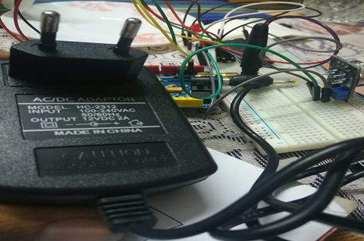

12 AMP 2 V SMPS Adapter:

This adapter is used to power the gsm module.

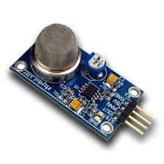MQ5 LPG GAS SENSOR:

As we can see in the fig there are four pins of this sensor.

The 5v pin is connected to pin 10 of atmega 32 to supply the power to this sensor.The ground pin is connected to the ground of atmega 32(pin11).It has another two pin AOUT and DOUT.AOUT gives analogue voltage and DOUT gives digital voltage.Actually the working principle of this sensor is such that the AOUT voltage of this sensor increases with the increasing density of gas in the surrounding.But DOUT only can be 5v or 0v,nothing in between.So its better to use analogue output A0,rather than digital output DOUT(As we will only see digital output voltage if the gas density exceeds a high threshold).Before connecting it to the atmega We must calibrate it in open air for a whole day,Because we need to count a threshold analogue voltage because we will after that compare AOUT voltage it this threshold to detect the gas.If we donot calibrate it this threshold will not be constant,it will fluctuate very rapidly.If this sensor detects increase of gas density,a green led will glow at the back side of this sensor which is the signal of high density of gas in the surrounding.

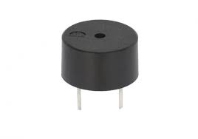

Buzzer:

Buzzer has two pins.The longer pin is connected to

PB0(pin 1) of atmega 32 and the other one is

connected to the ground of atmega 32.

If PB0 pin comes in active high state then buzzer will

sound.

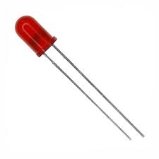

RED LED 5mm:

This led has two pins.The longer is connected to

Positive voltage and the other one is connected to

The ground.In our experiment we will connect the

Longer pin to the PB0(pin 0) and the other one to

Grnd (pin 11) of atmega 32.

Challenges Faced:

The first problem we faced here was to calibrate the gas sensor. After connecting the project for the first time we fixed a threshold to 4.5 v and it was working good.But after somedays I found its not working how much I try.Then I put it in open air for two days.Then I found that the actually the first threshold I thought was wrong,it should be 1.5 v.

The main problem was to connect the gsm module.At first we thought that it will be ok to give power to it by atmega 32.But the fact is after trying to do that our atmega32 got burned,USB ISP also didn’t work after that at all.Then we find that 5 v voltage by atmega is not enough,Then we power it by an adapter which’s voltage can vary from 0 to 10.5 volt.It didn’t work also.After that again we tried another adapter with 12V,2amp and this one worked fine.So this a compulsory work to power it by only this particular adapter otherwise not only the module will not work,there will be damage to our other components.

We had another problem when sending serial data to module from atmega.We found that sms is not going the given number.Then we adjust the dalay and found that 500ms was enough between any one serial data to be successfully sent.

The problems we often face is cheap enable program error.It happens when we burn the hex file to the atmega.Surprisingly there is no problem in code or in circuit.If it happens the only solution is to change the port of laptop which we use to connect usb isp to the burner.It also happened that we waited for an hour and changing ports to load the program.